**Submitted by:**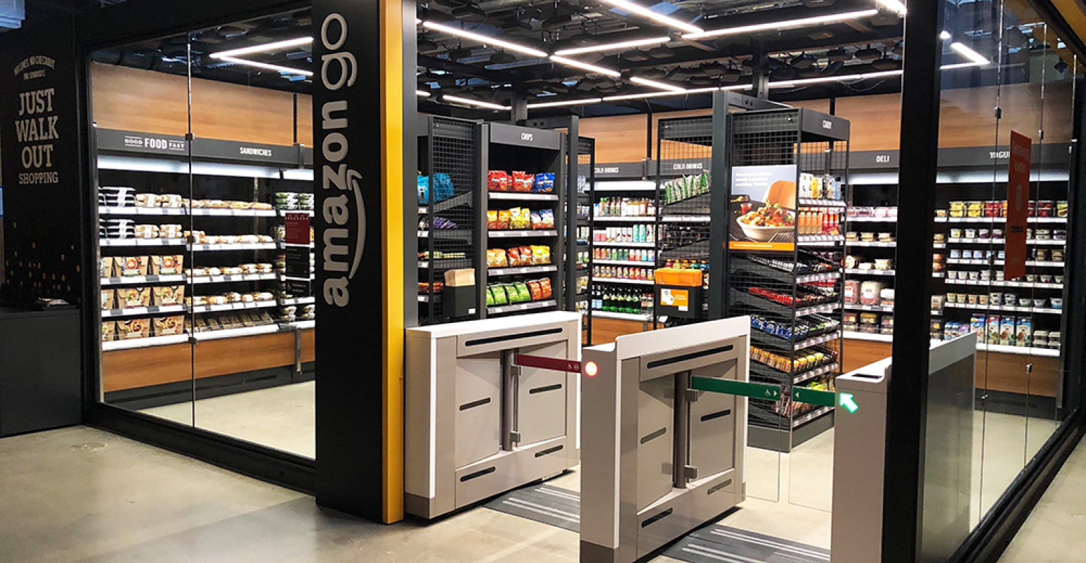

Riya Sachdeva 2022411

Rohak Kansal 2022412

Rohan Beriwal 2022413

Rohan Devgon 2022414

Rohan Indora 2022415

**Topic: Amazon Go Stores**

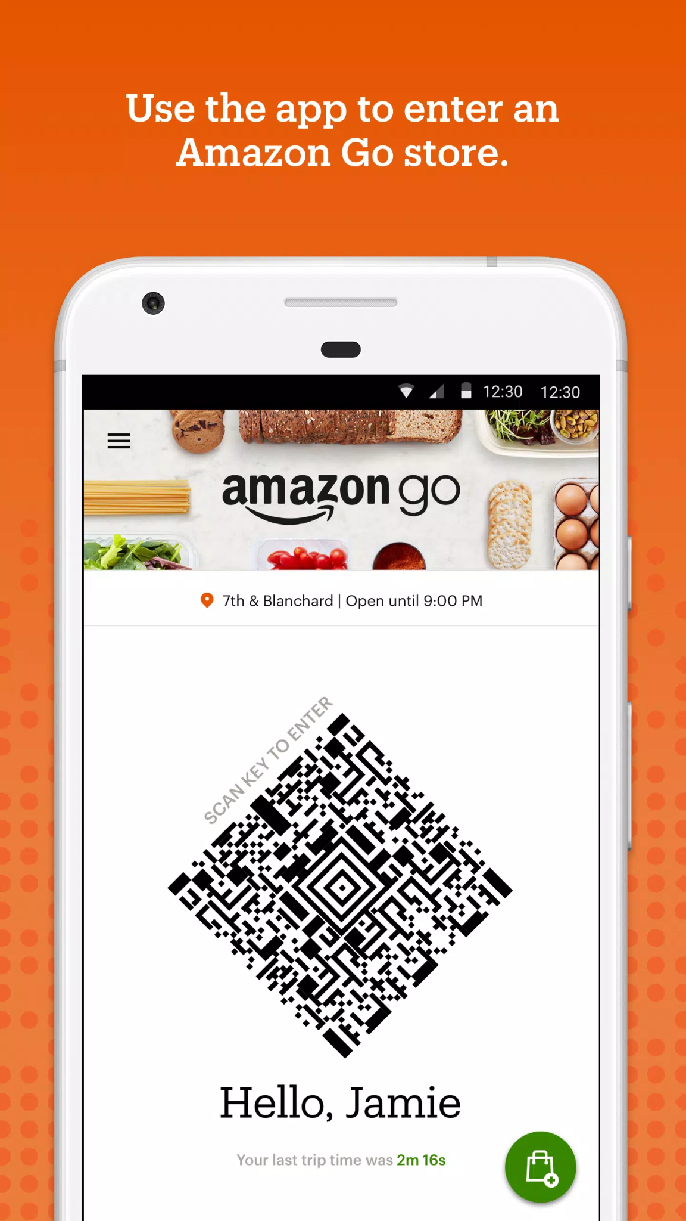

**Introduction**

Amazon Go is a chain of smart convenience stores, an ambitious venture of the online retail giant Amazon, that claims to be the “future of retailing.” The first store was opened for Amazon employees as a beta in its Seattle home market in late 2016, followed by a commercial opening in January 2018. To enter the stores, customers have to scan a QR code (on the turnstiles) generated on the Amazon Go app, and after they are done shopping, they can simply walk out. The bill is charged from their Amazon accounts. There are 29 Amazon Go retail stores in the United States and 6 Amazon Fresh grocery stores in the UK. A Business Insider report claims that Amazon plans to open another 100 stores in 2023 and 100 more in 2024.

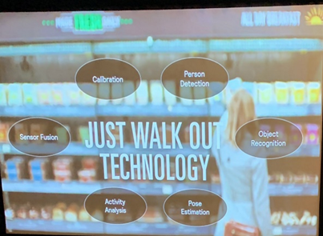

**Technology**

Amazon Go is the pioneer of a cashier-less shopping experience. Their stores are equipped with 'just walk-out technology' - a complex combination of computer vision, deep learning algorithms, and sensor fusion for purchasing, checkout, and payment steps associated with a retail transaction. Using a web of cameras and sensors, Amazon can track people in the store at all times, ensuring it bills the right items to the right shopper when they walk out without having to use facial recognition.

**Reception and Scope**

According to Yelp, almost all Amazon Go stores get an average rating of 4 to 5 stars, and the Apple app store has a 4.5-star rating, higher than even the Amazon shopping app. A calculation by Forbes suggests that Go stores are a $4.5 billion annual sales opportunity for Amazon. A Piplsay poll found that 59% of participants saw Go cashier-less stores as a threat to traditional supermarkets such as Walmart and Kroger. Other reports suggest that Amazon Go is planning to expand its reach into India and looking for ways to accept cash payments.

**Limitations**

1. The data collected by Amazon on how customers move within a store and what they buy is a significant privacy concern.
2. According to Recode, the store still needs human employees to function smoothly, i.e., to restock shelves, help with product locations, as fresh food chefs, etc. A human is also employed to check the IDs of people buying liquor and cigarettes.
3. Amazon’s rivals, Walmart and Microsoft, have collaborated to develop a better UX than Amazon Go. They must constantly upgrade and optimize their algorithms to stay ahead of their competitors.
4. Increased automation and reliance on AI will curb employment opportunities in an already bad economy.
5. The software isn’t yet capable of solving logistic issues like price changes, out-of-stock items, etc.
6. A report by Annex Cloud used data from almost 12 million shopping trips to determine that self-checkout raises the rate of loss by an average of 22%.
7. According to Francois Chaubard, CEO of Focal Systems: “In our analysis, we find that even though GPU compute is getting cheaper each year, the system will not prove a break even in a large format grocery store, compared to the status quo of operating the front end with cashiers, until after 2040.” In other words, running a store with traditional human cashiers is much cheaper at the moment.
8. The software charges people for whatever they pick up, even if another person walks out with it. So, people cannot help others by picking out or carrying things.
9. In a larger-format (38,000 ft2) Amazon Fresh grocery store in California, they have removed the Go technology and deployed shopping carts called Dash Carts, which suggests that Amazon Go’s technology does not work well at a large scale.

**Suggestions**

1. They must ensure that the data collected is not sold or misused. It should only be utilized to improve the UX.
2. They can ask people to verify their ages using some government-issued ID when making an Amazon account so that people can buy liquor/cigarettes at the store without the need for a human to confirm that they are of legal age.
3. Amazon can consider buying the 3D food printer technology and installing it in their stores to eliminate the need for human chefs. This will help in the complete automation of the store and also add a novelty factor to attract customers.
4. The stores must have a prompt alarm system that can contact the emergency services in case of theft, medical emergency, etc.
5. The hardware and software must be constantly upgraded in order to stay ahead of the competition, reduce installation costs and reduce losses due to self check-out.
6. The software must be modified to charge people for what they carry out, not what they pick. This will allow people to help young children and the elderly in the store.
7. To make the stores more accessible, they can provide wheelchairs inside. Further, they can add features in the app, like a voice assistant, to guide people to the products they need (for people with disabilities).
8. A few years down the line, they can develop smart shopping carts that will input the shopping list and pick out all the items themselves, without the need for the customer to even walk around the store in search of things.

**Sources**

<https://www.businessinsider.in/tech/i-shopped-at-amazons-cutting-edge-convenience-store-of-the-future-and-now-im-convinced-its-the-future-of-retail-for-better-or-for-worse/articleshow/65170424.cms>, <https://www.computerweekly.com/feature/Amazon-Go-is-now-the-right-time>, <https://www.adcocksolutions.com/post/is-amazon-go-store-technology-the-end-of-supermarket-checkouts#:~:text=The%20store%20is%20equipped%20with,will%20be%20emailed%20to%20them>, <https://www.atmmarketplace.com/articles/amazon-go-a-case-study-in-cashless-retail-pushback/>, <https://towardsdatascience.com/how-the-amazon-go-store-works-a-deep-dive-3fde9d9939e9>, <https://www.supermarketnews.com/retail-financial/amazon-go-draws-high-interest-us-shoppers>, <https://techcrunch.com/2022/09/29/amazon-go-india-plans/>, <https://www.annexcloud.com/blog/potential-problems-amazon-go-sellers-skipping-lines/>, <https://www.forbes.com/sites/andriacheng/2019/01/13/why-amazon-go-may-soon-change-the-way-we-want-to-shop/?sh=1797994c6709>, <https://www.wired.co.uk/article/amazon-go-seattle-uk-store-how-does-work>, <https://www.youtube.com/watch?v=NrmMk1Myrxc>, <https://www.manchestereveningnews.co.uk/news/uk-news/amazon-reported-planning-260-supermarkets-22177719>, <https://en.wikipedia.org/wiki/Amazon_Go>, <https://www.youtube.com/watch?v=zdbumR6Bhd8>, <https://www.amazon.com/b?ie=UTF8&node=16008589011>, <https://www.scrapehero.com/location-reports/Amazon%20Go-USA/>, <https://www.supermarketnews.com/sites/supermarketnews.com/files/styles/article_featured_retina/public/Amazon_Go_store_Macys_building_Seattle_0.png?itok=c4u2qNPP>, <https://towardsdatascience.com/how-the-amazon-go-store-works-a-deep-dive-3fde9d9939e9>, <https://www.atmmarketplace.com/articles/amazon-go-a-case-study-in-cashless-retail-pushback/>, etc